Experiment Number : 10 Date: 25/02/26

Implementation of Access Modifiers in Java

Aim:
Write a Java program to implement different access modifiers.

PRE LAB EXERCISE
QUESTIONS
- What are the 4 access modifiers available in Java?
• Default
• Private
• Protected
• Public

- Which access modifiers can be used in Java to control access to class members?
• Private
• Protected
• Public
• Default

IN LAB EXERCISE
Objective
To demonstrate different access modifiers such as Default, Private, Protected and Public using Java programs.
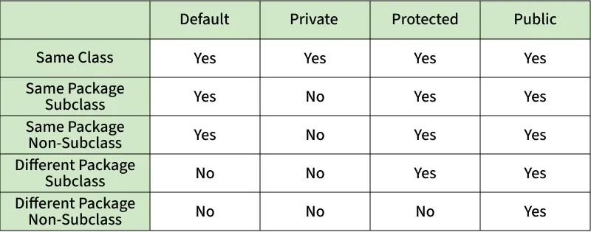
Fig: Comparison table of Access Modifiers in Java
Source Code
// Default Access modifier
class Car {
String model; // default access
}
public class Main {
public static void main(String[] args){
Car c = new Car();
c.model = "Tesla"; // accessible within the same package
System.out.println(c.model);
}
}
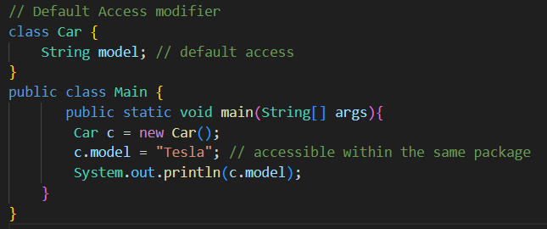
Output:
Tesla

//Private Access Modifier
class Person {
// private variable
private String name;
public void setName(String name) {
this.name = name; // accessible within class
}
public String getName() {
return name;
}
}
public class Geeks {
public static void main(String[] args)
{
Person p = new Person();
p.setName("Alice");

// System.out.println(p.name);
// Error: 'name'
// has private access
System.out.println(p.getName());
}
}
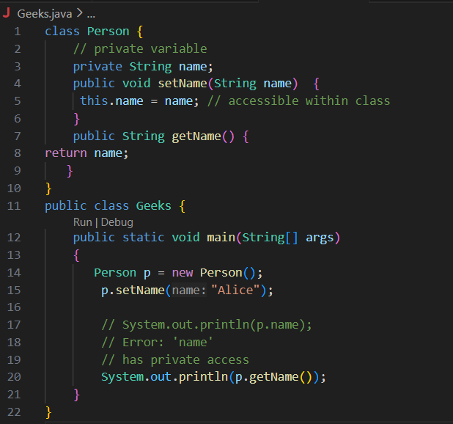
Output
Alice

//Protected Access Modifier
class Vehicle {
protected int speed; // protected member
}
class Bike extends Vehicle {
void setSpeed(int s)
{
speed = s; // accessible in subclass
}
int getSpeed()
{
return speed; // accessible in subclass
}
}
public class Main {
public static void main(String[] args){
Bike b = new Bike();
b.setSpeed(100);
System.out.println("Access via subclass method: "+ b.getSpeed());
Vehicle v = new Vehicle();
System.out.println(v.speed);
}
}
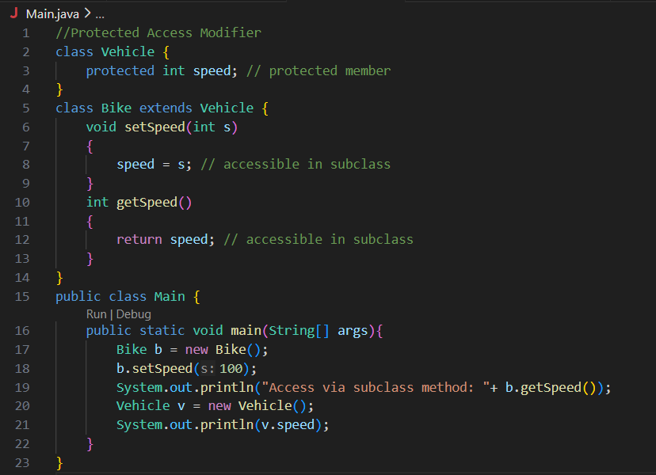
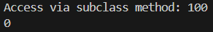
Output
Access via subclass method: 100
0

//Public Access Modifier
class MathUtils {
public static int add(int a, int b) {
return a + b;
}
}
public class Main {
public static void main(String[] args) {
System.out.println(MathUtils.add(5, 10)); // accessible anywhere
}
}
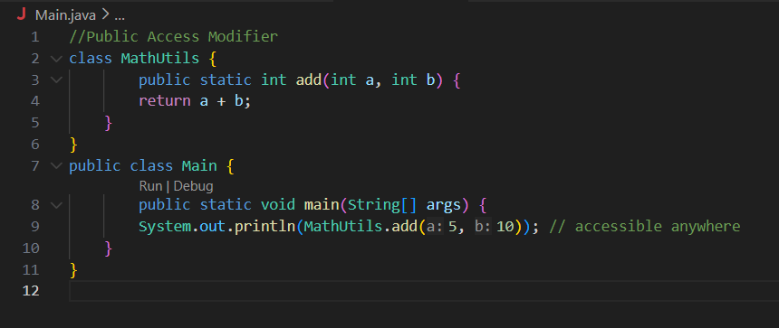
Output
15

POST LAB EXERCISE
  - Write a Java program to implement Default access modifier which has a default class within the same package and a default class from a different package.
• Default members are accessible only within same package.
• Not accessible from different package.

  - Which access modifier provides the highest level of access?

  - ✅ Public

ASSESSMENT

Description | Max Marks | Marks Awarded
Pre Lab Exercise | 5
In Lab Exercise | 10
Post Lab Exercise | 5
Viva | 10
Total | 30
Faculty Signature

Experiment Number :11 Date: 25/02/26

Implementation of multiple inheritance in Java using Interface

Aim:
Write a Java program to implement multiple inheritance using Interface.

PRE LAB EXERCISE
QUESTIONS
- Why Java does not support multiple inheritance using classes like that of C?
Because of the Diamond Problem (ambiguity problem).
- What is the primary purpose of an interface in Java?
- To store data using instance variables
- To define a contract of methods a class must implement
- To allow creation of objects
- To improve runtime performance
✅ B. To define a contract of methods a class must implement

IN LAB EXERCISE
Objective
To demonstrate how an interface in Java defines constants and abstract methods, which are implemented by a class.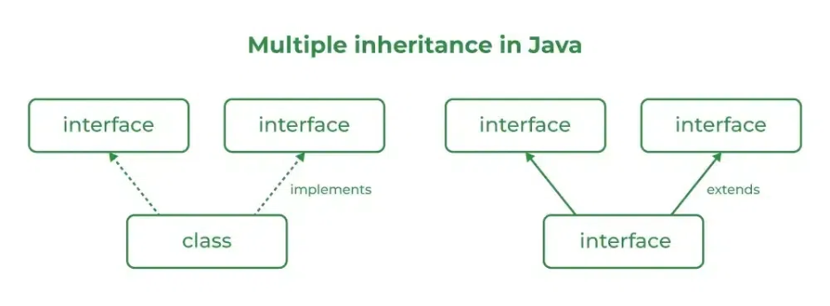

Source Code
import java.io.*;
// Add interface
interface Add{
int add(int a,int b);
}
// Sub interface
interface Sub{
int sub(int a,int b);
}
// Calculator class implementing Add and Sub
class Cal implements Add , Sub
{
// Method to add two numbers
public int add(int a,int b){
return a+b;
}
// Method to sub two numbers
public int sub(int a,int b){
return a-b;
}
}
class Example{
// Main Method
public static void main (String[] args){

// instance of Cal class
Cal x = new Cal();
System.out.println("Addition : " + x.add(2,1));
System.out.println("Substraction : " + x.sub(2,1));
}
}
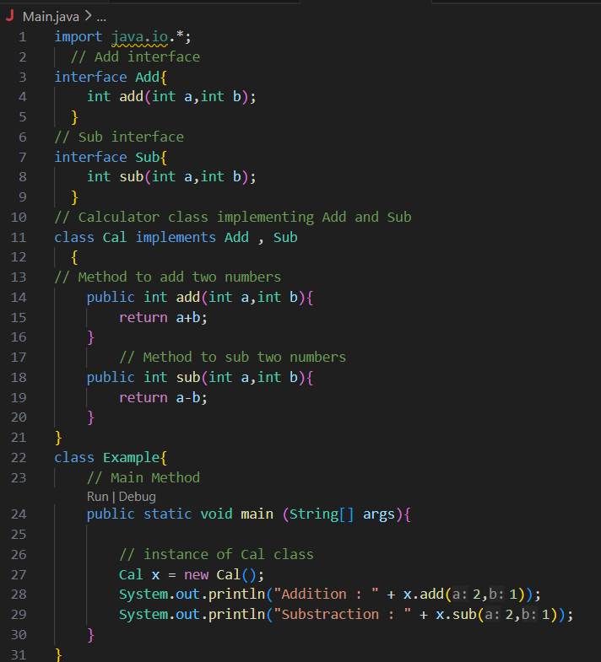
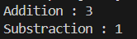
Outputs
Addition : 3
Subtraction : 1

POST LAB EXERCISE
  - Can a functional interface extend another interface?
Yes, but it must still contain only one abstract method.
  - Which feature was introduced in interfaces starting from Java 8?
- Constructors
- Private methods
- Default and static methods
- Final classes
✅ C. Default and static methods

ASSESSMENT

Description | Max Marks | Marks Awarded
Pre Lab Exercise | 5
In Lab Exercise | 10
Post Lab Exercise | 5
Viva | 10
Total | 30
Faculty Signature

Experiment Number : 12 Date: 25/02/26

Implementation of exception handling in Java
Aim:
Write a java program to implement exception handling.

PRE LAB EXERCISE
QUESTIONS
- What is exception handling in Java?
• It is a mechanism to handle runtime errors so that program execution does not stop abruptly.
- What is the purpose of using try-catch blocks in exception handling?
  - try → contains risky code
  - catch → handles the exception

IN LAB EXERCISE
Objective
To understand and implement exception handling through try-catch and finally blocks.
Source Code
import java.util.InputMismatchException;
import java.util.Scanner;
public class ExceptionHandlingExample {
public static void main(String[] args) {
Scanner scanner = new Scanner(System.in);
try {
System.out.print("Enter an integer: ");
int num = scanner.nextInt();
int result = 10 / num;
System.out.println("Result: " + result);
} catch (InputMismatchException e) {
System.out.println("Invalid input! Please enter an integer.");
} catch (ArithmeticException e) {
System.out.println("Cannot divide by zero!");
} finally {
scanner.close();
System.out.println("Program execution completed.");
} }
}
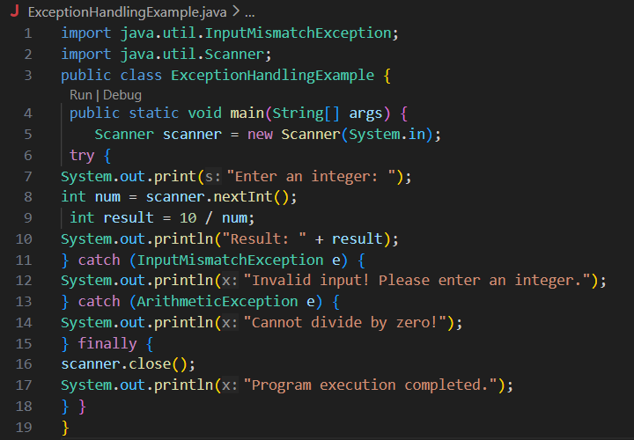
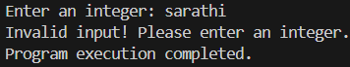
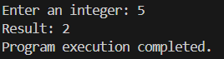
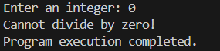
Outputs
Output 1 (Valid Input - Non-zero Integer):
Enter an integer: 5
Result: 2
Program execution completed.

Output 2 (Valid Input - Zero):
Enter an integer: 0
Cannot divide by zero!
Program execution completed.

Output 3 (Invalid Input - Non-integer):
Enter an integer: abc
Invalid input! Please enter an integer.
Program execution completed.

POST LAB EXERCISE
- What is the purpose of the Scanner object in the Java program?
To take input from the user.
- What exceptions are expected to be thrown in the code within the try block? Why?
  - InputMismatchException → if user enters non-integer
  - ArithmeticException → if divided by zero

ASSESSMENT

Description | Max Marks | Marks Awarded
Pre Lab Exercise | 5
In Lab Exercise | 10
Post Lab Exercise | 5
Viva | 10
Total | 30
Faculty Signature

Experiment Number : 13 Date: 25/02/26

Implementation of User-defined Exception in Java

Aim:
Write a java program to implement User-defined Exception.

PRE LAB EXERCISE
QUESTIONS
- What is Java custom exception?
A user-created exception class to handle specific application errors.
- What are the two types of custom exceptions in Java?
  - Checked Exception (extends Exception)
  - Unchecked Exception (extends RuntimeException)

IN LAB EXERCISE
Objective
To understand and implement Checked and Unchecked custom exceptions.
Source Code
Ex 1: // Custom Checked Exception
class InvalidAgeException extends Exception {
public InvalidAgeException(String m) {
super(m);
}
}
// Using the Custom Exception
public class AgeCheck{
public static void validate(int age)
throws InvalidAgeException {
if (age < 18) {
throw new InvalidAgeException("Age must be 18 or above.");
}
System.out.println("Valid age: " + age);
}
public static void main(String[] args) {
try {
validate(12);
} catch (InvalidAgeException e) {
System.out.println("Caught Exception: " + e.getMessage());
}
}
}

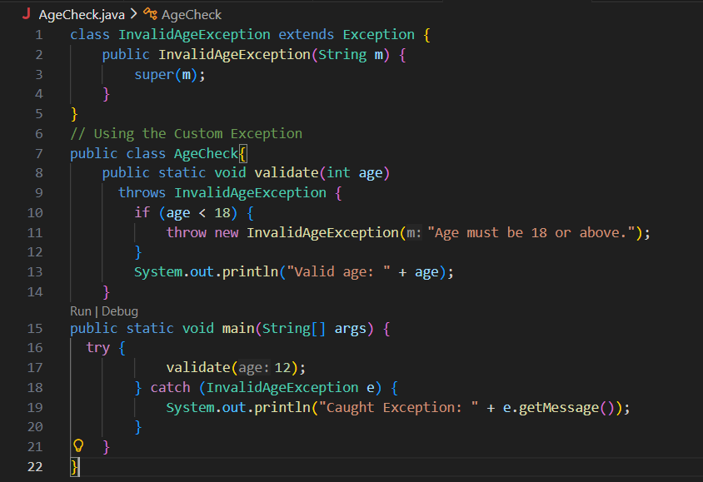

Output 1
Caught Exception: Age must be 18 or above.

Ex 2: // Custom Unchecked Exception
class DivideByZeroException extends RuntimeException {
public DivideByZeroException(String m) {
super(m);
}
}
// Using the Custom Exception
public class TestSample {
public static void divide(int a, int b) {
if (b == 0) {
throw new DivideByZeroException("Division by zero is not allowed.");
}
System.out.println("Result: " + (a / b));
}
public static void main(String[] args) {
try {
divide(10, 0);
} catch (DivideByZeroException e) {
System.out.println("Caught Exception: " + e.getMessage());
}
}
}
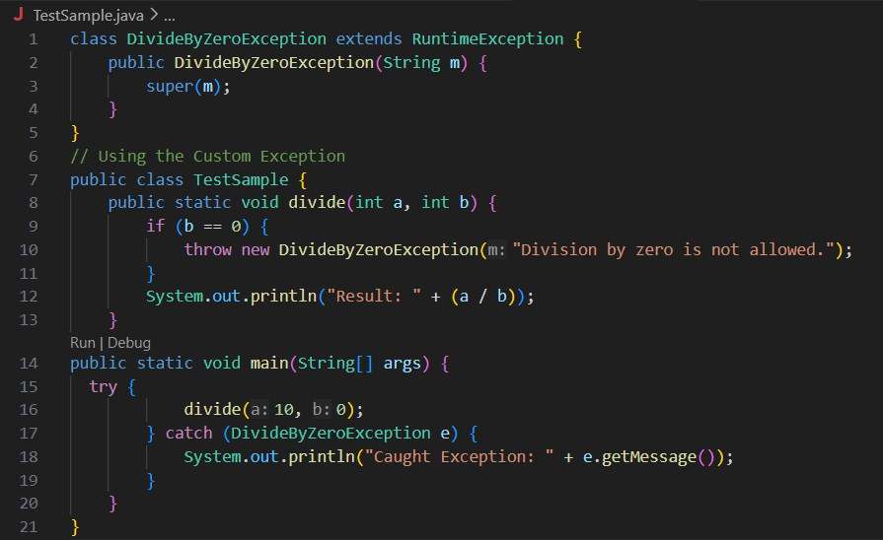

Output 2
Caught Exception: Division by zero is not allowed.

POST LAB EXERCISE
- What is required to create a custom exception in Java?
- Extend the Object class
- Extend the Throwable class
- Extend Exception or RuntimeException
- Implement the Serializable interface
✅ C. Extend Exception or RuntimeException

- List some use cases for the checked and unchecked exceptions.

Checked Exception:
- File handling
- Database operations
- Network errors
Unchecked Exception:
- Invalid input
- Arithmetic errors
- Business rule violations

ASSESSMENT

Description | Max Marks | Marks Awarded
Pre Lab Exercise | 5
In Lab Exercise | 10
Post Lab Exercise | 5
Viva | 10
Total | 30
Faculty Signature

